homework_3_1_ForHomework

* 运行结果：以下4张图片为gif的截图

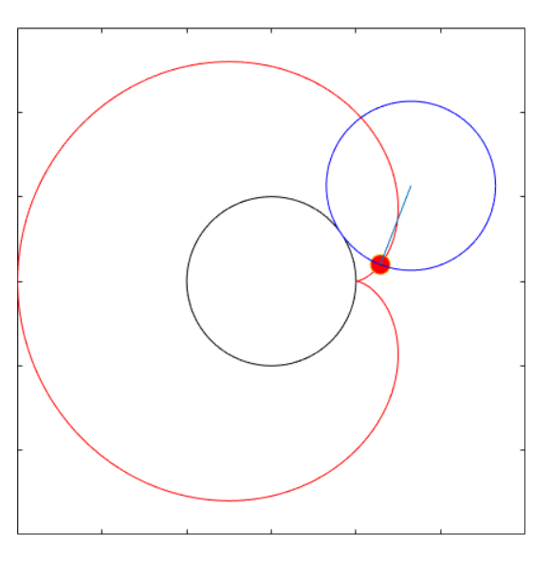 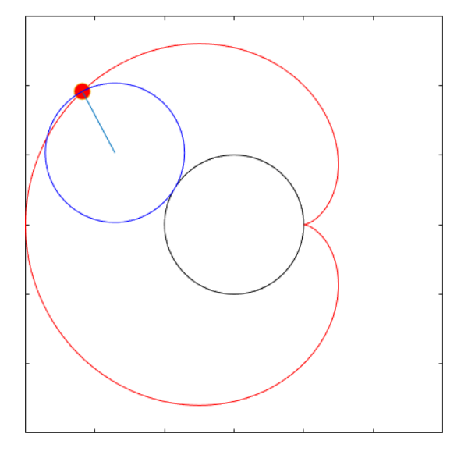

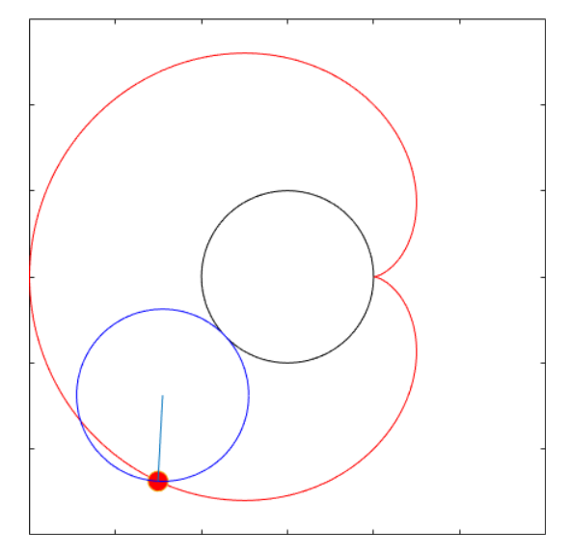 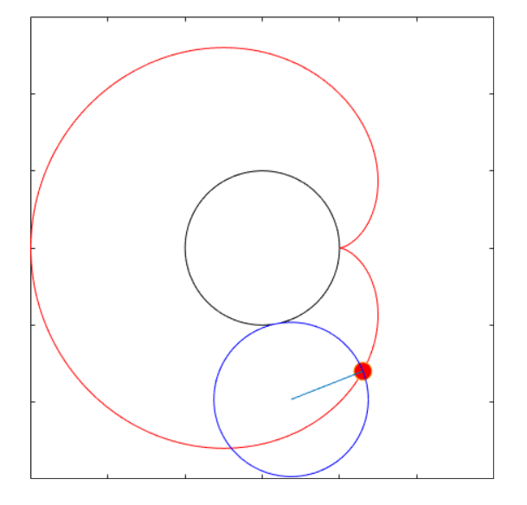

homework_3_1_ForFun

* 运行结果：直接看LyxCardioid和Lyx10Cardioid这两个动图即可